Anantha Lakshmi Institute of Technology and Sciences (ALITS)
Department of Data Science

Visualizing Housing Market Trends: An Analysis of Sale Prices and Features using Tableau
Functional Specification Document (FSD)

Project Name: Housing Market Trends using Tableau
Team ID: ALITS-DS-2026-HousingMarketTrends
Academic Year: 2026

Functional Specification Document
Document Control
Field | Details
Project Name | Housing Market Trends using Tableau
Team ID | ALITS-DS-2026-HousingMarketTrends
Version | 1.0
Prepared By | C Bhavani and Team

Project Overview
Visualizing Housing Market Trends: An Analysis of Sale Prices and Features using Tableau. Built on the Transformed_Housing_Data_2.csv dataset (21,609 records), the solution consists of four Tableau worksheets, one combined dashboard, and a five-point storyboard.
Modules Overview
Module | Description
Data Preparation Module | Transforms the raw housing dataset into Transformed_Housing_Data_2.csv
KPI Summary Module (Sheet 1) | Displays Count of records, Sale Price, and Basement Area totals
Price Distribution Module (Sheet 2) | Histogram of Sale Price bins — Total Sales by Years Since Renovation
Renovation Analysis Module (Sheet 3) | Pie chart of House Age distribution split by renovation status
Feature Comparison Module (Sheet 4) | Bar chart comparing bathrooms, bedrooms, and floors by house age
Dashboard Module (Dashboard 1) | Combines all worksheets into the Comprehensive House Price Analysis view
Storyboard Module (Story 1) | 5-point guided narrative of the dashboard's insights

Dashboard Walkthrough (Actual Build)
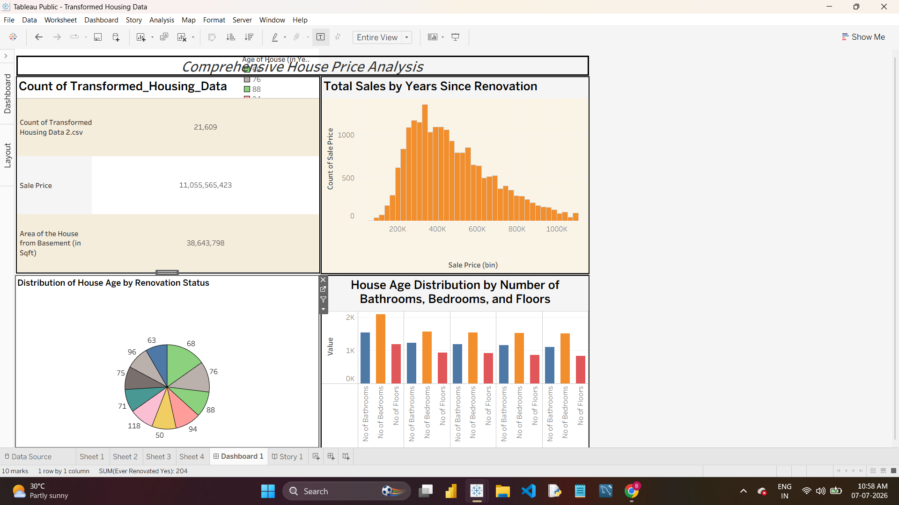
Dashboard 1 — Comprehensive House Price Analysis
Sheet 1 — KPI Summary
Displays three key measures: Count of Transformed_Housing_Data (21,609), Sale Price (11,055,565,423), and Area of the House from Basement (38,643,798).
Sheet 2 — Total Sales by Years Since Renovation
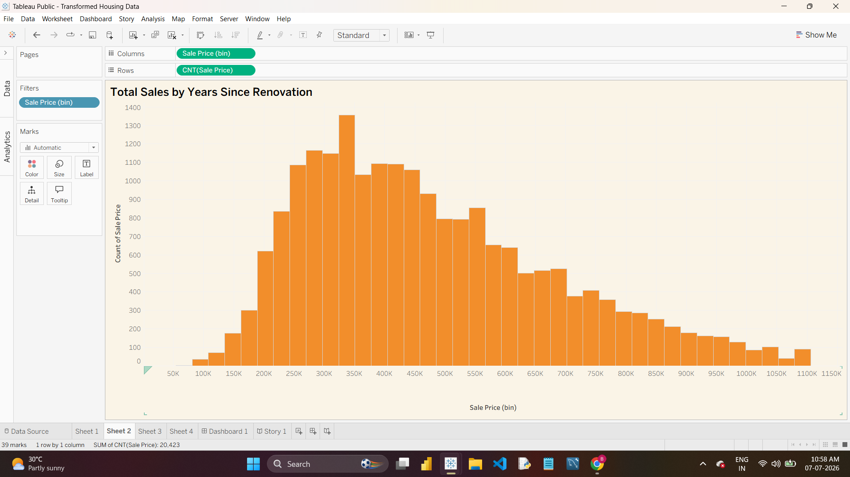
Sheet 2 — Sale Price Histogram
Sheet 3 — Distribution of House Age by Renovation Status
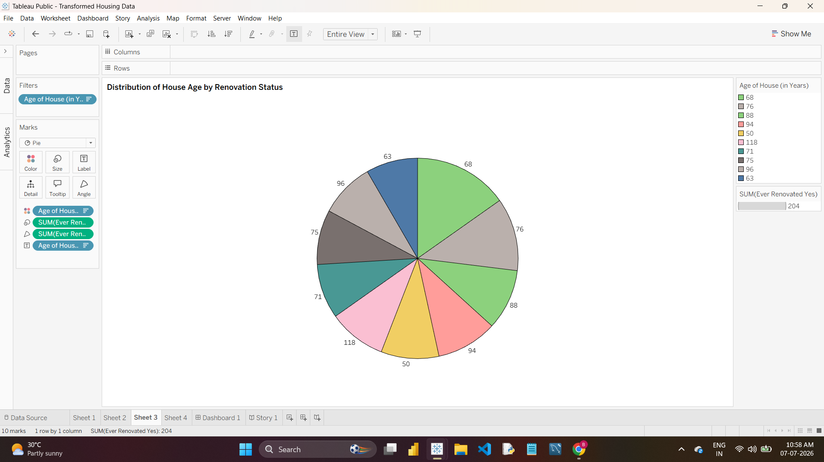
Sheet 3 — House Age by Renovation Status
Sheet 4 — House Age Distribution by Bathrooms, Bedrooms, and Floors
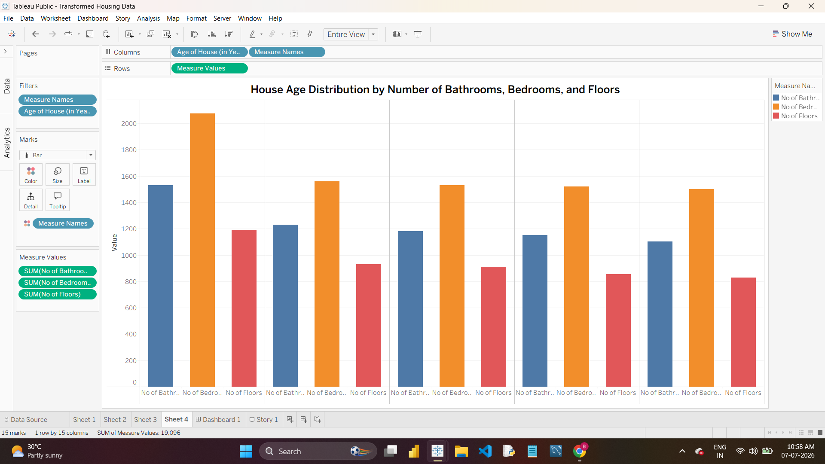
Sheet 4 — Feature Comparison by House Age
Design Considerations
- A warm cream/orange color palette was used consistently across the dashboard for visual coherence.
- KPI cards positioned at the top-left of Dashboard 1 for quick scanning.
- The Age of House filter is shared across all four worksheets for consistent cross-filtering.
- Tooltips are enabled on all marks to surface underlying values without cluttering the view.

